Dance Description Notes
- “Poussette” unmodified refers to the Playford shuttle‐style poussette, as distinguished from a draw poussette.
- Direction of turn singles, if not given, are to the R.
- "R&L" indicates hands, "circular hey" indicates no hands.
- CW/CCW = clockwise/counterclockwise.
- Unless otherwise specified, hand turns and circles are
once around.
- Corner/partner/neighbor changes are by R shoulder.
- “Diagonal” refers to places rather than people.
- “Cast R” means travel to the R rather than pull back R shoulder. Similarly for L.

Barbarini’s Tambourine
Longways duple (4/4), Walsh, 1741
A 1-4 1st corners cast to their R and dance a diagonal half fig-8, passing L shoulder in the middle, to change places (behind neighbor, around partner).
A 1-4 2nd corners repeat opposite (behind partner, around neighbor).
All are now diagonally opposite from where they started.
B 1-2 Fall back and cross over to own sides.
3-4 Back-to-back with neighbor.
5-6 Back-to-back with partner.
B 1-4 R&L, 4 changes.
5-6 2-hand turn partners.

Bob’s Boomerang
Longways duple improper (6/8)
Dance by Mike Richardson, 2000. Tune by Anita Anderson, 2000.
A 1-4 Ladies advance and retire.
5-8 Gentlemen set moving forward, turn single to place.
A 1-8 R-hands across, L-hands back.
B 1-4 Whole set dance single file CCW, crossing at the ends.
5-8 Dance single file back.
B 1-8 Ladies’ open chain (with original corner) over and back.

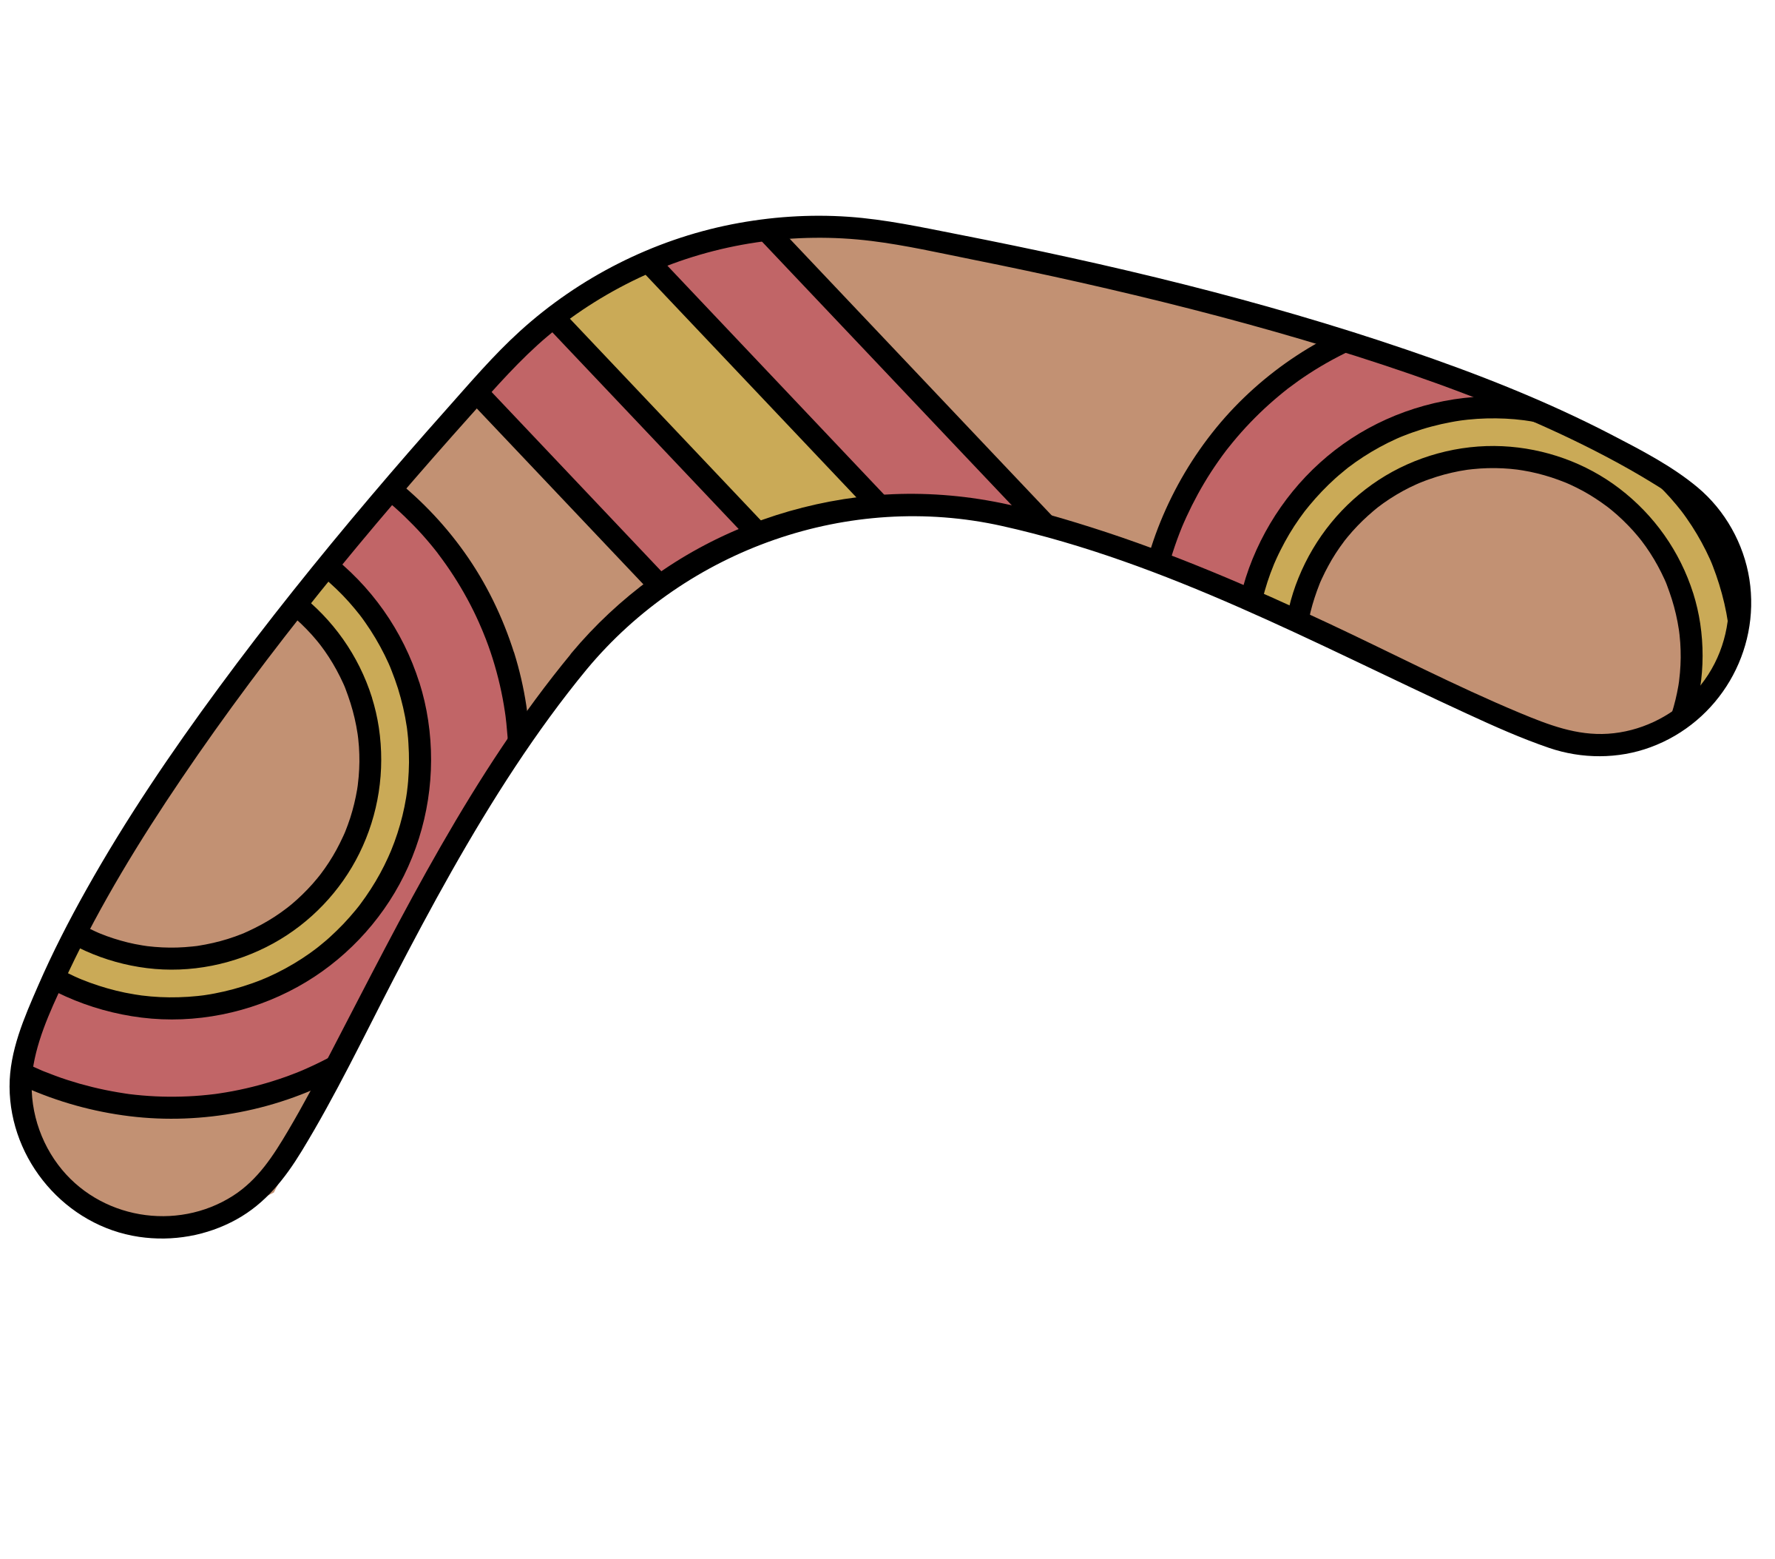
Charlene’s Celebration
4-couple longways (3/2)
Roodman, 2006. Tune: “Elizabethan Tango Man” by Charlene Thomson.
A 1-8 1s and 3s (odds) face down and 2s and 4s (evens) face up. Mirror hey for four on the sides, odds split evens to begin.
A 1-4 In fours, R-hand star, L-hand star.
5-6 Still in fours, half poussette CCW (the direction you’re already going). This is quick!
7-8 Ends cast one place toward middle while middles lead out to nearest end.
B 1-3 In fours, starting with partner, 3 changes of a circular hey.
4 Middles only do one more change by the L along the line.
5-6 In new fours, 1st corners cross, then 2nd corners.
7-8 In the same fours, circle L halfway.

Cobbler's Hornpipe
3-couple longways (3/2)
Jenny Beer, 2008. Tune: “Cobbler’s Hornpipe.”
A 1s and 2s turn 2-hand, then half poussette CW (1st corners push).
A 1s and 3s do the same.
B 1-2 Circle 6 halfway, middle couple pulling in to form lines.
3-4 Lines fall back for 3 steps and come forward for 3; on the last step, “flip” to change places with partner and stay facing each other.
B Lines fall back and come forward, and 1s at the top cast one place, 3s leading up. 2s at the bottom turn single out or stand still.
A Corners Pass & Turn: 1s pass by the R shoulders and change places with 1st corners. Those corners turn R-hand in center as 1s loop to face in and pass original corners who move out to place. 1st couple pass R shoulders to face 2nd corners.
A Repeat figure with 2nd corners, 1s pass R shoulders to cross to own side.
BB Repeat previous BB, 1s in the middle casting to the bottom, 3s leading up, and 2s turning single out (or standing still).
Companions
Longways duple (4/4)
Dance by Victor Skowronski, 2003,
Tune: “Ronde II, Mon Amy” by Tielman Susato (1551).
A 1-2 All circle L single-file one place.
3-4 All face in and balance into the center and back.
A Repeat, finishing progressed and improper.
B 1-4 1st diagonals start a chevron by passing R shoulders. As they back across the set into neighbor’s place, those neighbors cast (into the place next to them).
B All half-poussette, 1st woman and 2nd man (the people who cast) pushing to begin. Release hands early; the 2nd corners continue backing up to form the ends of a line of 4 and the 1st corners form the middle of the line facing each other. The order from caller’s L to R is M2, M1, W2, W1.
continued next page
Companions—continued

C 1-6 Six changes of a hey for four, 1st corners beginning by passing L shoulders. End with 1st corners facing out at the ends, improper, and 2nd corners facing each other in the middle, proper.
C 1-3 2nd corners gypsy L shoulder 3/4 while 1st corners loop to their right.¹
4-6 All gypsy partner R shoulder 1-1/4 times to progressed place.

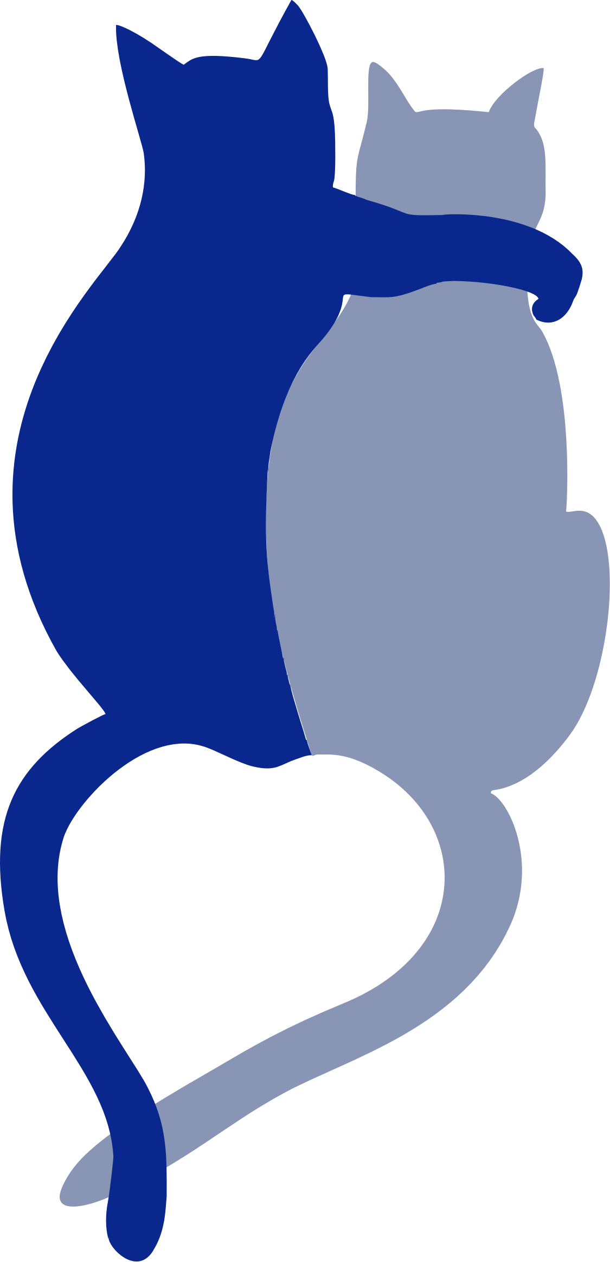
Harlequin in the Mud
Longways duple (6/8). Johnson, c.1742.
A 1-8 1s cross R and turn R to face down, and then 1st man go down outside W2, up the middle and turns R into his partner’s place while 1st woman go down the middle and up outside 2nd man into her partner’s place.
A 1-8 2s cross L and turn L to face up, and then 2nd man go up outside 1st man, down the middle and turns L into his partner’s place while 2nd woman go up the middle and down outside 1st woman into her partner’s place. All are now improper.
B 1-2 Partners facing but not taking hands, 1s slip down into 2nd place, man down the middle and woman down the outside, while 2s slip up into 1st place. All are progressed and improper.
3-8 Rights and Lefts, 3 changes. All are in partner’s original place.
B 1-4 Second diagonals cross R shoulders, then first diagonals.
5-8 All 2-hand turn partner.

Kersty’s Jig
Longways triple (6/8). Dance by Jo Hamilton,1994.
Tune: The Fair Witness.
A 1s and 2s dance Rights and Lefts. At the end keep L hand and face your neighbor.
A L-shoulder hey for three on the sides. 1st man end facing out.
B 1-4 1st woman dance down the middle, cast up around 3rd woman and end in second place. Meanwhile,
1st man dance down behind the men’s line, in below 3rd man and up the middle to second place. 2s move up on bars 3–4.
5-8 1s and 2s RH star.
B 1-4 1s and 3s LH .
5-8 All turn partner LH.
This dance was devised as a review of some basic figures. Kersty (pronounced: care-stee) is our cat. Friends introduced her to a toy called a Cat Dancer and we have as much fun watching her “dance” as she has in doing her “jigs.”

King’s Maggot
3-couple longways (3/2).
John Young, Dancing Master Volume 2, 1718.
A 1-4 1s cross, cast, 2-hand turn. 2s move up.
A 1-4 1s (improper) lead through the 3s, cast back, 2-hand turn 3/4 (face up/down) and pass R shoulders to face the ends.
B 1-4 1s turn first corner L hand, partner R hand to face 2nd corner.
B 1-2 1s turn second corner L hand.
3-4 1s turn partner R hand 3/4 to middle place proper.
C R shoulder hey for three across the set, M up, W down.
C L shoulder hey for three across at the other end of the set. 1s finish in the middle, proper.
D 1-2 1s (quick) back-to-back, ending close.
3-4 They turn single R into the sidelines.
D 1-4 1s and 3s half Right and Left, then R-hand turn partner half and fall back into line.
The order is now 2,3,1.

Lilli Burlero
Longways duple (6/8)
Playford, The Dancing Master, 1690.
A 1s lead through 2s and cast back to place.
A 2s repeat, leading through 1s.
B 1-4 1st corners cross. 2nd corners cross.
5-8 All fall back a double and come forward, turning single.
B 1-2 Pass R shoulders with partner (to own side), and turn back on neighbor.
3-4 Pass R shoulders with neighbor, backing up.
5-8 Partners face and 3 changes of a circular hey, skipping.

The Lissome Lass
Longways duple (3/4). Dance by Sharon Green, 2016. Tune: “Paulina” by Patti Cobb 2016.
A 1-4 2nd corners balance forward and back, turn single.
5-8 2nd corners 2-hand turn 1-1/2, fall back.
A 1-4 1st corners balance forward and back, turn single.
5-8 1st corners 2-hand turn 1-1/2, fall back.
B 1-4 Partners back-to-back R shoulder.
5-8 Neighbors back-to back R shoulder.
9-10 Starting with partner, 2 quick changes of a circular hey.
11-12 Partners 2-hand turn once round into…
13-16 Double Mad Robin 1½ times.
For Melissa Monty.

Mr. Hamilton’s Inauguration
Longways duple (9/8). Joseph Pimentel, 2006. Tune by Debbie Jackson, 2006.
A 1-2 Neighbors L-hand turn once around (“the person beside you”).
3-4 2nd corners Hole-in-the-Wall cross, passing L shoulders.
A 1-2 Partners R-hand turn once around (“the person beside you”).
3-4 1st corners Hole-in-the-Wall cross, passing R shoulders.
B 1-2 Circle L half.
3-4 Partners 2-hand turn half.
5 Open to face neighbors: set to the L.
6 Turn single over R shoulder, into…
7-8 In 4some: single-file circle CW half-way, to progressed positions, facing new neighbors to start again.

Moonflower
Longways duple improper (3/4)
Susan Kevra, 2017. Tune by Rachel Bell, 2016.
A 1-4 Women set and turn single.
5-8 All circle L.
A 1-4 Men set L and R and turn single L.
5-8 All circle R.
B 1-4 Balance the ring, and partners roll away across the set.
5-8 Balance again, and neighbors roll away along the line.
B 1-4 Long back-to-back with partner.
5-8 2-hand turn partner 1-1/2.

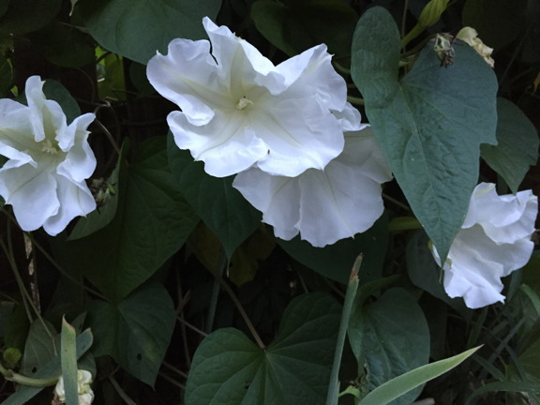
Passages
Longways duple improper (3/4)
Kalia Kliban, 2008. Tune: “Ye Banks and Braes.”
A 1-4 1s lead down (near hands) and California Twirl. 2s do not move.
5-8 Lead back and 2-hand half turn to home.
9-16 2s repeat, leading up. End facing the 1s.
B 1-2 Circle L halfway.
3-6 Half poussette CW, women moving forward to start.
7-8 With partner, 2-hand turn halfway and open toward neighbors.
9-10 Set to neighbors, without creeping forward.
11-12 Drop hands with partner and pass neighbor by R shoulders.
13-16 2-hand turn partner.

Red and All Red
3-couple longways (2/4). Thompson, 1757.
A 1-4 All set forward and turn single R to places.
5-8 2-hand turn halfway, ending close, and fall back. All are improper.
A 1s set to each other, take inside hands and set to 2nd woman (who acknowledges). Circle L with her, then 1s face 2nd man.
B 1-6 1s set to 2nd man (who acknowledges) and circle L with him.
7-10 1st man keeps his partner’s hand and draws her to stand behind the men. He continues CW round the set and stands behind the women. On bar 10, the two men and the two women turn towards each other to face their respective #1 and make circles of three.
11-14 Threes circle L once round. Break hands where the 2s are joined with the 3s to make a circle of six.
continued on next page

Red and All Red—continued

B 1-6 Circle L once round.
7-10 Top and bottom couples continue CW halfway around the outside of the set (M2 at the top, and W3 at the bottom drawing partners) to own side.
11-14 All 2H turn. The order is now 3,1,2.
Repeat 2x.

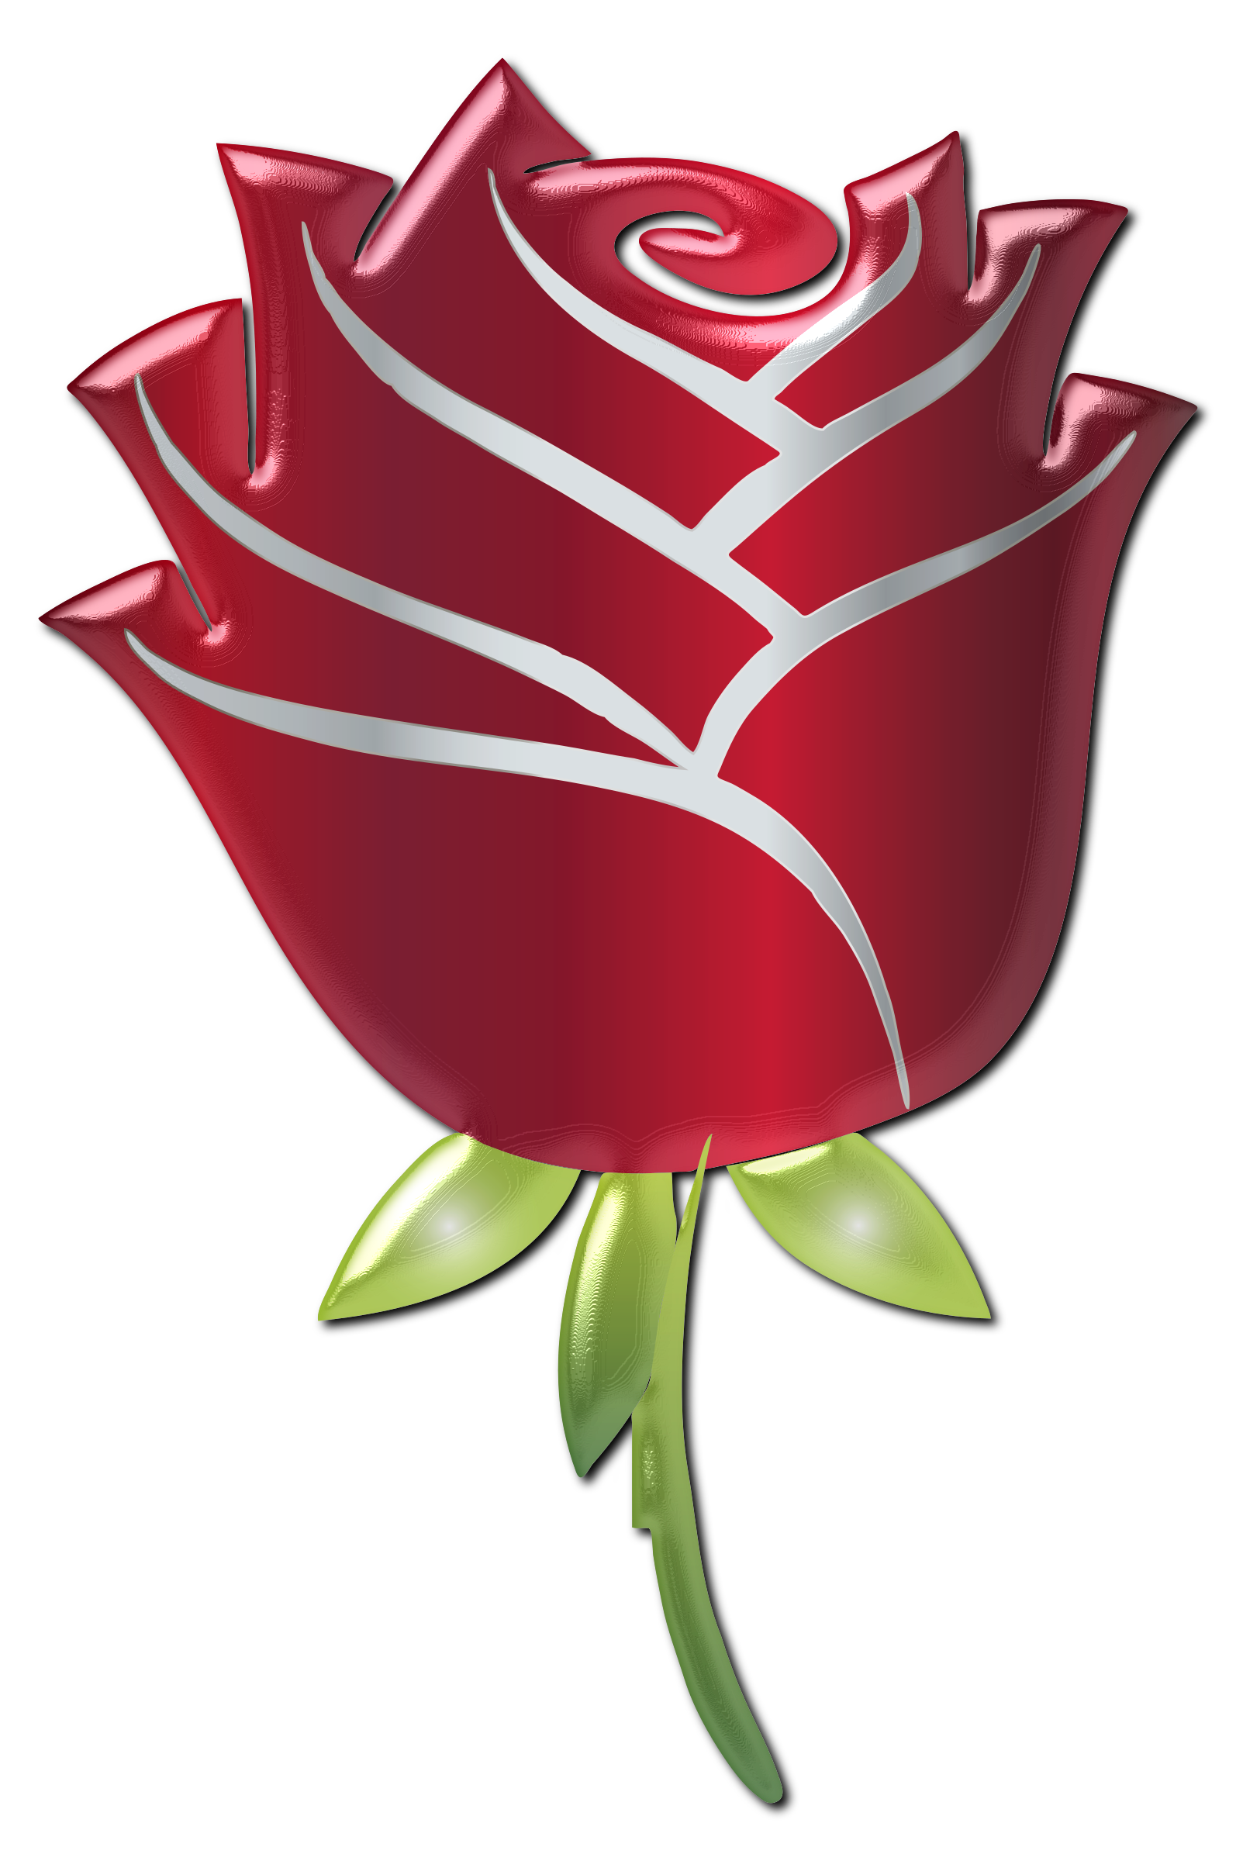
Rose
3-couple longways (2/4)
Inga Morton, 1989.
A 1-4 1s lead through the bottom (2s move up) and cast to the middle.
5-8 1s lead through the top and cast to the middle.
A 1-4 1s R-hand star (3 hands) with the couple on their R (W up, M down).
5-8 1s, passing each other L shoulder, lead their star in single file CCW around the other star. End in lines of 3 across the set (facing up/down).
B 1-4 Lines forward and back. Those in the middle, you will be the new leaders.
5-8 Three men and three women R-hand star.
B 1-4 New leaders, passing each other L shoulder, lead your star around and end in lines on the sides, improper.
5-8 Pass partner L shoulder and turn alone. The order is now 3,1,2.

Wa’ Is Me, What Mun I Do?
Longways duple (3/4).
Aka Epsom New Wells. Playford, 1696.
A 1-4 1st man set to the two women, then circle 3 hands with them until he is in 2nd woman’s place.
5-8 Dropping hands with 1st woman, he leads them around behind 2nd man until he is in 2nd woman’s original place. (The women are now above and the men below.)
A 1-8 2nd man repeat, finishing in 1st woman’s place. Everyone is now diagonally opposite from where they started.
B 1-2 All fall back and come forward.
3-4 All chassé L one position. (Everyone is now beside partner.)
5-6 Lead partner out at the side, turn and lead back.
7-8 All cast L one position, to original place.
9-12 1st corners meet and fall back, then 2nd corners.
13-16 R&L, partners facing, 3 changes.

Wakefield Hunt
Longways triple (6/8) triple progression.
C&S Thompson’s 1779 Collection.
A 1st man cast off while 2nd man moves up. He sets to and turns 3rd woman, finishing in 2nd man’s place.
A 1st woman does the same.
B Circle 6 hands round and back.
B 1s dance gates down through the 3s, then up through the 2s.
C 1s R-hand star with the 3s, then L-hand star with the 2s.
C 1-6 1s and 3s circular hey, partners facing, 3 changes. (2nd progression)
7-8 1s dance down outside the next couple, who move up. (3rd progression)

Young Damon’s Flight
3-couple longways (9/8).
Kynaston, 1717. Walsh, 1719.
A 1-2 1st man, taking inside hands with 2nd man, leads him CW behind 1st and 2nd women while they balance back (3 beats), then come forward to the men’s line and turn individually R into...
3-4 Circle 4 hands halfway. Men are home; women are in each other’s place.
A Repeat, 2nd woman leading CCW behind the men, who turn L. Now 2,1,3.
B 1-2 All set to partner.
3-4 1s cross R shoulder and loop R outside the set (around 1st corner).
Meanwhile, 2s and 3s meet partner and turn single toward the center of the set (reverse cloverleaf).
5-8 Heys for 3 across the set, 1st & 3rd men, and 1st and 2nd women passing L shoulders to begin. 1s finish between the end couples, facing each other.
Continued on next page
Young Damon’s Flight--continued

B 1-4 1s fall back (2 bars), then cast R into second place proper.
5-6 1s half figure-8, man up through the 2s and woman down through the 3s, into second place improper.
7-8 1s 2H turn half and lead to third place while 3s cast up.

This transition has been nicknamed “smerge,” from smoosh and merge.

